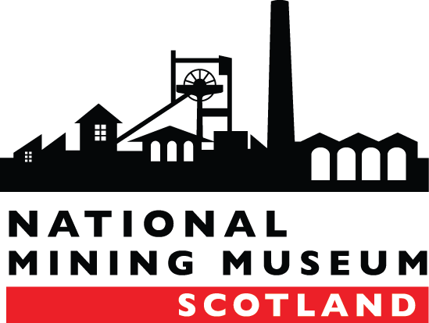

**NATIONAL MINING MUSEUM SCOTLAND**

|  |  |
| --- | --- |
| **JOB DESCRIPTION** | |
| **Post Title:** | Curator |
| **Salary:** | £31,000 |
| **Contract:** | Full Time (35hrs) |
| **Reports to:** | Chief Executive |
| **Responsible for:** | Assistant Curator and Volunteers |

**BACKGROUND**

The National Mining Museum Scotland is an independent trust and the national body responsible for the preservation and interpretation of Scotland’s Mining Heritage. The museum holds collections of national significance and is on the site of the Lady Victoria Colliery, built in 1895 as Scotland’s first super-pit. The museum offers a wide range of activities and events to a diverse and growing audience. The visitor experience includes access to the collections through tours and exhibitions and an award winning education programme.

**PURPOSE OF POST**

To be responsible for the curation, care and development of the National Mining Museum Scotland collections. Develop specialist knowledge, including research activity, and enable the widest possible access to the collections through inquiry, research and exhibitions. Ensure that the reputation of the National Mining Museum is enhanced at every opportunity through external links and partners, giving specialist advice on subjects relating to the museum’s collections and related industries.

**KEY RESPONSIBILITIES**

1. Lead as Specialist Curator for the collection and be responsible for the curation of NMMS collections, working in line with the museums policies and procedures and the sectors professional standards. This covers activities relating to acquisitions, loans, collections care, documentation, exhibitions and research.
2. Lead on accreditation and recognition reviews and reporting and liaise with Museums Galleries Scotland and other sector leaders as required.
3. Lead on the development of NMMS’s exhibition programme ensuring that the programme is of the highest quality and reflects the strategic plan of NMMS.
4. Promote greater understanding of the significance of the collection and reinforce the National Mining Museum Trust’s standing within the Industrial Heritage sector.
5. Represent National Mining Museum Scotland and the collections in the academic and cultural sectors as required and give professional advice.
6. Support and contribute to NMMS education and outreach activities and events programme to help develop and attract new audiences.
7. Support and lead on new initiatives to develop the profile of and access to the collections.
8. Work closely with the NMMS management team to present and interpret the collection to the public in a compelling and engaging manner, taking every opportunity to raise external funds for our work.
9. Report and liaise to the Scottish Mining Museum Collections Trust on all aspect of the collections management.
10. Work with NMMS staff to develop knowledge of potential funding sources and develop funding bids for further approval.
11. Manage the Assistant Curator and monitor their work in accordance with NMMS policies and procedures.
12. Oversee all aspects of the NMMS volunteer’s programme, including the recruitment, induction and general support of their work, to ensure their contribution is focused and recognised.
13. Ensure compliance and understanding of overarching policies including health and safety, fire evacuation and data protection.
14. Undertake any duties at the request of the line manager which are commensurate with the role, including other project work within the Trust.

**PERSON SPECIFICATION**

|  | Essential | Desirable | Measured by |
| --- | --- | --- | --- |
| **Qualifications** | | | |
| Relevant degree or qualification or equivalent experience. |  | x | Certificate to be produced at Interview |
| **Experience** | | | |
| Experience in museum/visitor attraction or similar environment. | x |  | Application form; interview questions; |
| Experience in collection management in museum or similar environment and implementing collections care policies and procedures. | x |  | Application form; interview questions; |
| Experience and understanding of sector professional practice and standards including recognition and accreditation. | x |  | Application form; interview questions; |
| Experience of undertaking research for dealing with museum acquisitions or enquiries. | x |  | Application form; interview questions; |
| Experience of developing exhibitions and research work. |  | x | Application form; interview questions; |
| |  | | --- | | Knowledge and experience of using computerised documentation systems for recording and research purposes. | | x |  | Application form; interview questions; probation period |
| **Skills and Attributes** | | | |
| Ability to be well organised and have strong planning and problem solving skills | x |  | Application form; interview questions; probation period |
| Experience in project management. |  | x | Application form; interview questions; probation period |
| Excellent communication skills, interpersonal, written and verbal. | x |  | Application form/ interview questions |
| Proven IT skills in word processing, databases, spreadsheets & web/internet. | x |  | interview questions; probation period |
| Ability to manage budgets and write funding applications. | x |  | interview questions; probation period |
| Highly motivated individual, able to meet tight deadlines and to manage workload priorities. | x |  | interview questions; probation period |
| Ability to be part of the museum’s management team and to help drive forward the museum’s strategic plan | x |  | interview questions; probation period |
| Ability to be a good team leader and to manage staff and volunteers. | x |  | Application form/ interview questions |
| **Other** | | | |
| Flexible, able to work evenings, weekends and public holidays. | x |  | Interview questions; probation period |
| Be approachable and have a friendly disposition |  | x | Interview questions; probation period |
| Ability to work in a busy office environment | x |  | Interview questions; probation period |